**StepTest Evaluation**

My chosen testing plan strategy will be to test my program based on the age of the user (to work out Max Heart Rate) and five heart rate inputs. I will predict what the outcome of the slope, y-intercept and aerobic capacity should be, and see if my program gives me the expected outcome.

I will conduct 4 tests with different age and heart rate values.

On the first test, I will use all 5 heart rate samples (1-5) and see if the result matches my expected result.

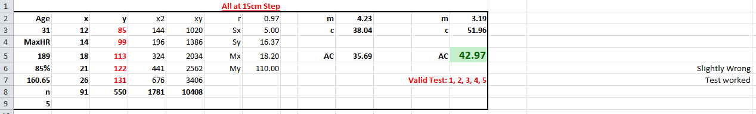

On the second test, I will use 4 heart rate samples (1-4) and see if the result matches my expected result.

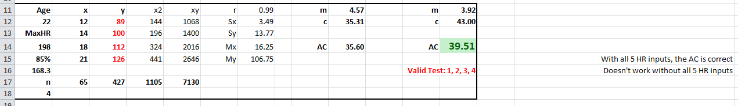

On the third test, I will use 3 heart rate samples (1-3) and see if the result matches my expected result.

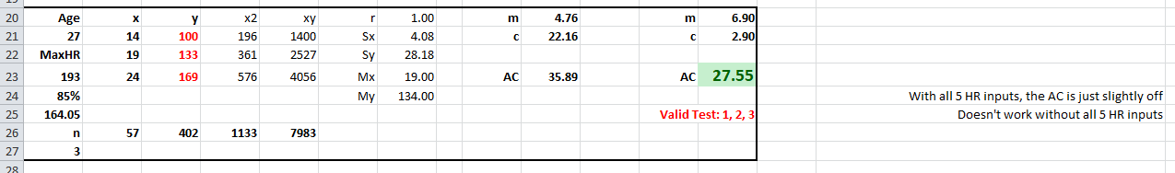

On the fourth and final test, I will use just 2 heart rate samples (2-3) and see if the result matches my expected result.

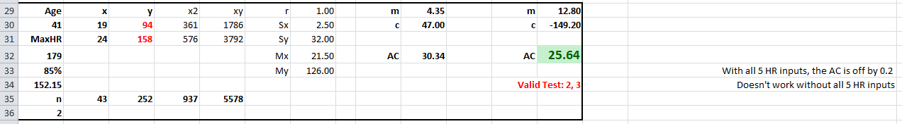

**What are the differences between expected and actual results?**

On the first test, I received the expected outcome from my input data. This test was successful.

For the next three tests, my program would not execute unless all heart rate values were inputted.  
I decided to add the extra heart rate values and update the slope and y-intercept to see if I still received the expected outcome.

On the second test, the outcome for the aerobic capacity was correct.

On the third test, the outcome for the aerobic capacity was slightly off by a few decimals.

On the fourth and final test, the outcome for the aerobic capacity was off by 0.2.

**Does my solution differ from my original design?**

Yes.

**What are the differences and explain why?**

The GUI still uses the majority of the core design elements; however I chose to replace the positions of each element to look more professional.

On form 1, I chose not to include a file drop down menu and instead included a "Save" and "Reset" button to achieve the same outcome. I thought this would be easier for the user.

I also didn't use a "Weight" textbox for the user to input their weight as this is not included in the calculation.

I removed the "Import Group Data" button as I was unable to get this function to work.

I was also unable to get the fitness rating calculation to work. Instead, I produced a random result from an array of expected results to use as a substitute until it is fixed.

I added "Save User Details" & "Save All Results" buttons to allow the user to save certain aspects of the results that was necessary.

The graph displaying the results is also displayed in form1, in place of the "Import Group Data" button as I did not use this function in the end.